Contents

An invitation to change the world

- Memo from the children of the 22nd century 1
- Across time and space 1

One World Week 2

Christian development agencies 3

Stories from Irish churches 4
Trade 5

Fair Trade 6

- The Fairtrade Foundation 6
- Traidcraft 6
- Producer’s Story: Banana Growing in the Philippines 7
- Stories from churches 7

A Rocha – Christians in Conservation 9

Climate Change 10

- Introduction 10
- Operation Noah 10

Reflection: an orb 11

World Development Movement 11

Prayers

- Prayer for Sustainable Development 12
- Week of Prayer for World Peace 12
- International Prayer for Peace 12

Stories from eco-congregations 13

A directory of useful organisations 15

An invitation to change the world…

Memo from the Children of the 22nd century

To: Churches across Britain and Ireland

Place: Planet Earth

Date: The start of the 22nd century

Dear Mothers and Fathers,

We write to invite your church to play a role in helping to care for the environment and nurture the well-being of people across the earth. It is now vital to plan and act to ensure that the needs of your generation are met without compromising the ability of our generation to enjoy life in fullness too. Some of your contemporaries say that it can’t be done. We say that it must be done!

Imagine that you are in a large Ark called Planet Earth. Instead of having two of every creature on board, you have the whole created order! Your challenge is to manage the finite stocks and renewable resources so that you and we, and those that will follow us, can have a share. You must also ensure that the rest of creation is respected and not desecrated. We don’t want to be left with your waste in the form of pollution and a ravaged earth. It is a tall order, and one that requires your immediate thought and action, for the well-being of tomorrow’s world is in your hands this day.

On behalf of tomorrow’s children

Across time and space

We live in an increasingly global society. A stone cast in a pond in one place can cause ripples in places far and wide. A hiccup in a commodity market can spell hunger for a farmer in a developing nation. An environmental accident in one nation can quickly spread down wind and down stream to other nations. Neither economics nor environmental issues/incidents obey international, political or geographical boundaries. This linkage applies to our lifestyles. The way that we choose to live can have an impact, for good or for ill, on people in developing nations and the environment across the world, today and for future generations.

This module is designed to help churches and individuals identify those areas where they can make a positive impact on the well-being of the environment and the poorest people in developing nations. It features information about issues and campaigns together with ideas for action.

“Justice and ecology are linked indissolubly”
- Archbishop Desmond Tutu
One World Week

One World Week (OWW) is your chance to join thousands of others, just like or not at all like you, in doing your bit to celebrate, learn and act for a fairer world.

One World Week grew out of a need to:

- learn about what’s going on in that world – both on our doorsteps and far away
- celebrate the good things about being part of one diverse yet interconnected world
- take action to change the things that cause injustice, poverty and degradation.

OWW springs into life when thousands of activists in Ireland and the UK and around the world prepare eight days each October as a focus for celebrating and sharing the richness and diversity of the world we all inhabit. Drawing on the inspiration of an annually changing theme, churches and community groups hold educational and celebratory events to build understanding and links between people.

The following illustrates the diversity of OWW activities:

- Stockton URC held a OWW quiz with food cooked from around the world  - Peruvian and Jamaican cooks offered culinary experiences in Hertfordshire  - A group from Calne, Wiltshire held a children’s Caribbean drumming workshop  - Churches Together in Lytham St Annes held an ecumenical celebratory service  - Woking Cinema Club screened a rare film from Senegal | - Slough One World Festival performed poetry in diversity  - A Church in Wallasey hosted a ‘one world’ open morning with talks and displays  - A Cardiff group protested at deaths in East Timor  - Haslingden litter bug eaters made a garden out of a grot spot  - In Masaka, Uganda, the Youth Organisation events include playing The Global Game and a football match

How could your church celebrate and mark OWW?

Resources
The OWW office provides an exciting, easy-to-use Action Kit each year, to help you plan OWW events, or to incorporate OWW into existing programmes and events.

Contact:
One World Week, PO Box 2555, Reading RG1 4XW. Tel. 0118 9394933
Email: enquiries@oneworldweek.org, Website: www.oneworldweek.org

OWW Ireland, Website: www.developmenteducation.ie

Quote

“My picture of a green church is a community committed to caring for the earth,
a church co-operating to steward the earth’s resources,
Christ’s body collaborating across the globe.”

~ Rev Penny Jones, Minister, St John’s Rookhope Anglican/Methodist Church.
Christian development agencies

Some of the leading development agencies in Britain and Ireland were established by churches to bring good news to the poor across the world. These agencies include Christian Aid, Cafod, SCIAF, Trocaire and Tearfund. A list of contact addresses is given below.

The work of the development agencies has its origins in offering Christian care to the most needy. The organisations undertake a wide variety of work including:

- long-term development work, often in partnership with the world’s poorest communities
- disaster/emergency relief in times of need
- research and analysis of poverty issues
- campaigning issues affecting the world’s poorest
- educational work to raise awareness of poverty issues and how to bring about change

Through their work several of the agencies have identified environment as a key issue in development work and the alleviation of poverty. In terms of development work, environmental considerations are usually considered in project work because ultimately taking care of the environment benefits people too. For example, working to conserve forests and trees can reduce soil loss and help to maintain sustainable agriculture, so enabling people to provide sufficient food. In terms of disaster/emergency relief Christian Aid have identified that 9 of the last 11 so-called natural disasters that they have responded to were caused by climate change with a strong link to global warming. It suggests that many of the victims are literally paying the price of other people’s profligate lifestyle.

For more information about Christian development agencies, contact one of the following agencies:

Trócaire:
Maynooth, Co Kildare, Republic of Ireland
Tel. 01629333, Fax: 01 6290661, Email: info@trocaire.ie, Website: www.trocaire.org

50 King Street, Belfast BT1 6AD
Tel. 028 9080 8030, Fax: 028 9024 3692, Email: info@bl.trocaire.org

Christian Aid:
Christian Aid Ireland, 17 Clanwilliam Terrace, Grand Canal Dock, Dublin 2, Ireland.
Tel. 016110 801, Fax: 00 353 1 4973880, Email: caidroi@iol.ie

Christian Aid Northern Ireland: Christian Aid, 30 Wellington Park, Belfast BT9 6DL
Tel. 02890 381204, Fax: 02890 381737 Website: www.christianaid.ie

Tearfund:
Republic of Ireland: 5-7 Upper O Connell Street, Dublin 1,
Tel:+353 (0)1 878 3200 Website: www.tearfund.ie

Northern Ireland: Rose House, 2, Derryvolgie Ave, Belfast BT9 6FL Tel. 028 906 82828

VITA:
73a Blessington Street, Dublin 7
Tel: 01 8820108/9 Website: www.vita.ie

CAFOD (Catholic Fund for Overseas Development):
Tel: 020 7733 7900 Website: www.cafod.org.uk
Stories from Irish churches:

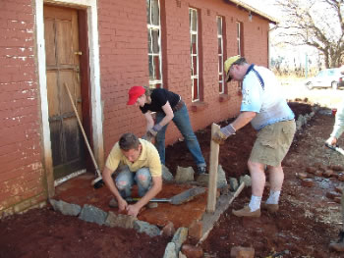
The United Dioceses of Cashel and Ossory run a Global Awareness section in their annual Diocesan Environmental Awards. Past winners have included the dioceses’ two Bishops’ Appeal representatives.
Rathfarnham Parish, Dublin sponsors a school project in a shanty town on the outskirts of Johannesberg, South Africa.
Three years in a row clergy and parishioners spent time there building, painting, gardening and playing with the children.

The children and teenagers of Rathfarnham Quaker Meeting, Dublin held a cake sale to raise funds for VITA. The €300 they raised enabled VITA to plant three oak trees in Marley Park, Rathfarnham, and 270 moringa trees in Ethiopia and Eritrea. Moringa trees are known as miracle trees as they provide food, fuel and shelter.
Whitechurch Parish, Dublin sponsors a number of projects in developing countries. Parishioners are currently helping to build a health centre and a pineapple factory in Rwanda where the parish has already helped install a water scheme, giving local people clean and accessible water.
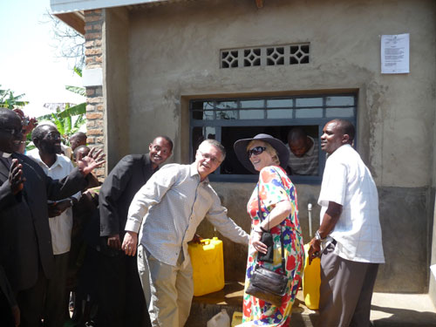

People from churches all over Ireland have taken part in Stop Climate Chaos actions, including street demonstrations, bell-ringing events and a mass lobby of TDs. Eco-Congregation Ireland, Trócaire and Christian Aid organised an ecumenical prayer service in Christ Church Cathedral, Dublin, on behalf of Stop Climate Chaos in the run up to the UN conference on climate change in Copenhagen in December 2009. The former president of Ireland, Mary Robinson, was guest speaker. See http://ecocongregationireland.org/archives/732.
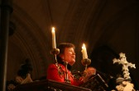

Trade

As the 21st century begins, several major Christian development agencies are focussing some of their campaigning work on the issue of trade. The following are some thoughts on trade, drawn from the OWW 2000 Ecumenical Worship Anthology.

People and the Earth are God’s creation and the goods of the Earth are intended for all to share. These are fundamental principles of Christian belief. For a Christian, people are always more important than profit. Rich countries and businesses do not just have rights, but also responsibilities towards people and the environment. Human lives should not be sacrificed on the alter of the new god of free trade. Justice demands that if trade is carried out between two partners who are not equal in power or wealth, every effort must be made to ensure that the trade is fair. What would global trade look like if people and the Earth mattered?

“Not to enable the poor to share our goods is to steal from them and deprive them of life. The goods we possess are not ours, but theirs.”
St John Chrysostom

Listening and responding to God’s word…

Listen to this, you that trample on the needy and try to destroy the poor of the country. You say to yourselves, “We can hardly wait for the holy days to be over so that we can sell our corn. When will the sabbath end, so that we can start selling again? Then we can overcharge, use false measures, and tamper with the scales to cheat our customers. We can sell worthless wheat at a high price. We’ll find a poor man who can’t pay his debts, not even the price of a pair of sandals, and we’ll buy him as a slave.”  The Lord, the God of Israel, has sworn, “I will never forget their evil deeds.  Amos 8:4-7 |  | Our choice could  tip the balance in favour of the poor  and lighten the load of those weighed down  We could level inequality  and distribute warehouse mountains  Share out the wealth  that was never ours to hoard  Turn the tables  on those who play the markets  We could stockpile generosity  and speculate in hope  Sell up our share of selfishness  and settle for the dividends of solidarity  For added value  build portfolios of justice  Or an ISA in the growth  of the Kingdom of God  Buy shares in trust and act in faith  risk our securities to find a richer life  May the percentage of our interest  in people rise  and may we be the prophets of hope.  Sophie Stanes/Cafod

For more information on trade-related issues contact either One World Week or a Christian development agency (contact details on previous page).
Fair Trade

The Fairtrade Foundation

The Fairtrade Foundation was established by Cafod, Christian Aid, New Consumer, Oxfam, Traidcraft and WDM. It works to ensure that marginalised and disadvantaged third world producers get a better deal. The independent Foundation awards a Fairtrade Mark to products that meet internationally recognised standards of fairtrade. The founding organisations have been joined by the Women’s Institute.

Fairtrade aims to make a real difference to people lives by:

- Challenging the conventional model of trade, and offering a progressive alternative for a sustainable future.
- Empowering consumers to take responsibility for the role they play when they buy products from the third world

Contact:
Fairtrade Mark Ireland, Carmichael House, North Brunswick St, Dublin 7.
Tel 014753515 Website: www.fairtrade.ie

The Fairtrade Foundation, Suite 204, 16 Baldwin’s Gardens, London EC1N 7RJ
Tel. 020 7405 5942, Fax: 020 7405 5943,
Email: mail@fairtrade.org.uk, Website: www.fairtrade.org.uk

Traidcraft

Traidcraft is a trading company that aims to ‘fight poverty through trade’.

Traidcraft was established to provide an alternative way of trading to ensure that families in developing countries get a fair share of the wealth generated by their own skill and effort and the resources of their land. Traidcraft:

- pays people in the ‘third world’ fair prices
- gives them credit when they need it
- works with producers for a better future

Traidcraft’s primary aim is to promote fairtrade and it recognises that environmental issues are important, not least for many of their producer partners. Consequently Traidcraft has developed an environmental policy. This policy includes the following:

Traidcraft’s mission is to ‘fight poverty through trade’ and as a Christian response ‘we strive to respect people (including future generations) and the environment, and to be transparent and accountable. We have a duty to respect the integrity of God’s creation and to act responsibly towards it. People and the environment are inextricably linked, and a healthy environment is vital for us all. Both the poor in developing countries and we in the UK depend on fertile soils, clean water and other environmental resources for our livelihoods and health’.

Producer’s Story: Banana Growing in the Philippines

The Panay Fair Trade Center (PFTC) was established in 1991 by a women’s association as a ‘not for profit’ venture that supplies Traidcraft with banana chips. In addition to ensuring a fair deal for farmers and producers, PFTC is also concerned about environmental issues and is actively encouraging organic farming. Cataline Buscar, a member of the association said:

One of our problems in our district in that our products are bought at a very low price. The middleman benefits more. Selling our bananas to fair trade facilitators like PFTC has helped us to earn more from what we sell. Bananas are a survival food as well. During lean months (May to August) we eat this cooking type of banana as a supplement to rice. Now we are eating only organically grown vegetables.

Contact:
Traidcraft, Kingsway, Gateshead NE11 0NE.
Tel: 0191 491 0591, Fax: 0191 482 2690
Email: comms@traidcraft.co.uk, Website: www.traidcraft.co.uk ADD

Stories from churches …

Dundrum Methodist Church, Dublin was the first ‘Fairtrade’ Church in the Republic of Ireland to officially make a commitment to serve only fairly traded tea and coffee at church events. Members have been encouraged to lobby local shops and supermarkets to stock fairly traded goods.

Dunkineely Methodist Church, Co Donegal held a Fairtrade Chocolate Party that proved a hit with all ages in the community! As well as chocolate fondues and chocolate fountains, there were Fairtrade chocolate samples galore as well as Fairtrade video clips and games. The event was held in support of the Stop the Traffic movement, which aims to combat the traffic of children in the chocolate-producing industry (see www.stopthetraffik.org).

The Diocese of Kerry had a Fairtrade display during its Earth Week 2010.

Kinsale Transition Town has a Fairtrade sail permanently flying in a highly visible location on a hill outside the town.

Rathfarnham Parish, Dublin invited Beni Oburu, a Kenyan woman who picked coffee leaves as a child, to speak about Fairtrade to the young people of the parish. On another occasion the sermon was about Fairtrade and home-made goodies, baked with Fairtrade ingredients, were served after the service.

The eco committee at Rathfarnham Quaker Meeting, Dublin made a display of Fairtrade goods that can be purchased in local shops to encourage members of the meeting to purchase Fairtrade food and drink, where possible. The Sunday School children baked goodies using Fairtrade ingredients to serve with coffee.

The Parish Church of St Mary the Virgin in Easington Village held a Fairtrade “Chocolate Evening”. They had fun and games, quizzes associated with the display they had up about the production of chocolate, and coffee and cake. The evening was very well attended by children and their parents and as a result the church was able to send £94 each to Christian Aid and Acton Aid.

Stockton United Reformed Church has run a Traidcraft stall for over 10 years. Staffed by a willing rota of volunteers, it stocks a supply of ‘core’ goods and also has catalogues available for perusal from which it takes orders. Whilst the stall aimed to break even from the outset, it has generated a profit each year which goes towards social responsibility activities and outreach. It has been remarked that the Traidcraft stall acts as an additional incentive for people to come to worship week-by-week!
St Mary the Virgin, Easington,
Co. Durham host a display of fairly-traded (and environmentally-friendly goods) for sale in their local supermarket to raise members awareness of their availability.
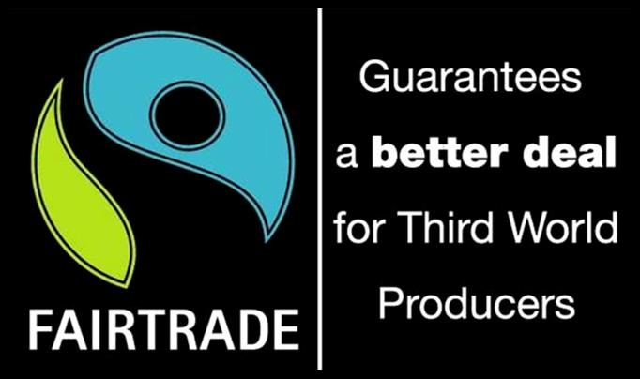

Barnstaple Parish Church held a ‘Parish Eco Day’ to encourage the congregation to change their personal lifestyles. Part of the day focussed on how our personal lifestyles can contribute to global problems. The congregation learnt about food by example: the refreshments were entirely home grown, locally produced or fairly traded goods. The food was extremely tasty and everyone was fed to capacity (coffee, lunch and tea) for only 50p each!

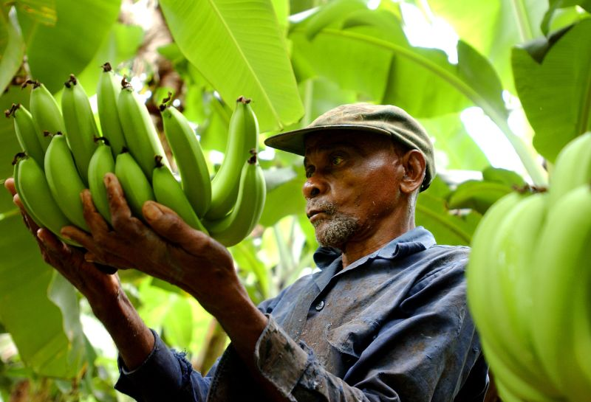
Dundee Church of Scotland Presbytery has become a Fairtrade Presbytery. Almost 70% (and rising!) of charges in the presbytery use Fairtrade tea and coffee and a range of Fairtrade produce is available and served at Presbytery meetings and other events. They have also raised awareness of their efforts through the media.

A Rocha – Christians in Conservation

The story of A Rocha

A Rocha is an international conservation organisation working to show God’s love for all creation. It began life in 1983 when the A Rocha Trust was formed. A Rocha’s first practical project was to establish a Christian field study centre in Portugal, which opened in 1986 on the Alvor estuary. In 1994, with the Portuguese project under national management, the UK Trustees decided to respond to requests for help from elsewhere. In the period 1997-2004, new A Rocha projects have been established in fourteen countries spanning five continents: Europe, North America, South America, Africa and Asia. There are national membership schemes in each country.

Some snapshots from A Rocha International

Cruzinha, Ria De Alvor – Portugal. In the first 18 years since the establishment of the field study centre and bird observatory in south west Portugal in 1986, thousands of visitors have taken part in the environmental education programmes and over 400 volunteers and students have been trained, many of whom continue to be active in environmental issues. The database at Cruzinha now holds records of over 60,000 birds ringed, while extensive studies of plants and fungi, moths and butterflies have given a firm basis for influential reports and articles on the Algarve's environment. Proposals for reserve status for the Alvor Estuary stem directly from A Rocha studies.

Arabuko-Sokoke Forest – Kenya. A Rocha Kenya was formally established in 1998 and opened the Mwamba Bird Observatory and Field Study Centre in Watamu, in the coastal district of Malindi, in 2002. Malindi is home to some of the richest and most diverse habitats in the whole of Kenya. The Arabuko-Sokoke Forest alone is home to at least 5 globally endangered species and has been designated a UNESCO world heritage site. However, a growing population and high levels of poverty put a huge strain on the relationship between local people and their environment. By working with local communities, A Rocha Kenya aims to achieve the long-term conservation of threatened habitats and species in this area.

Aammiq Marsh – Lebanon. The Aammiq Marsh is Lebanon's most significant remaining freshwater wetland, one of all too few in the Middle East. This major stop-over site for migrating birds is under severe threat. Due to the work of A Rocha since 1997, the decline in the habitats of the wetland has been reversed. Current efforts are focused on protecting the marsh through scientific study, practical conservation and environmental education.

Minet Country Park - UK. The initial focus for A Rocha’s work in the UK has been the A Rocha Living Waterways Project in Southall and Hayes, West London, which was launched in early 2001. Located in a heavily built-up, culturally diverse area the project aims to open up the wonders of God's creation to people who have little chance to enjoy the beauty of the natural world at first hand. A Rocha Living Waterways has worked with local landowners, Hillingdon Council and other community groups to turn a 90 acre wasteland site between Southall and Hayes into the Minet Country Park, with recreational space and nature conservation areas.

Contact: A Rocha Trust, 3 Hooper Street, Cambridge CB1 2NZ Tel/fax: 01387 710286, Email: international@arocha.org, Website: www.arocha.org
Climate Change

Introduction

There are many ways in which our individual and corporate lifestyles in Britain and Ireland affect the global environment and impact on other peoples and species both now and in the future. Probably the most serious of these issues is Climate Change, sometimes known as “global warming”.

Human activities, particularly the burning of oil, coal and gas, produce carbon dioxide and other gases, known as ‘greenhouse gases’, which trap heat from the sun. It is now clear that these activities are affecting the global climate. The effects of climate change are already starting to be visible and are likely to get worse for some time to come, even if we succeed in cutting back our greenhouse gas emissions. They include rising sea-levels, an increase in storms and flooding in some places and drought in others and changes in the distribution of some disease-bearing organisms.

People in Britain and Ireland contribute as much as 50 times more to climate change than those in the poorest countries. We use a great deal of energy in our homes, our industries and businesses and in transport. But it is the poor who will feel its worst effects. It is estimated that, by 2050, rising sea levels, severe weather and crop failures could create 150 million refugees. Even in the UK, an estimated 5 million people are at risk from increased flood and storm damage.

Section 7 on caring for church premises and Section 10 on personal lifestyles both give advice on saving energy in church and at home. Reducing the amount of energy we use reduces our impact on the climate.

Operation Noah

Operation Noah is a Climate Change Campaign set up by Christian Ecology Link and endorsed by the Environmental Issues Network of Churches Together in Britain and Ireland. It calls on people to:

- Sign the Climate Covenant urging the UK government to lead the search for a global solution to Climate Change
- Take action themselves by switching to green electricity
- Spread the word with the resources available

If you would like to get your church involved, contact Operation Noah at the address below. They can supply free campaign leaflets and other information.

Operation Noah, 9 Nuthatch Drive, Earley, Reading, RG6 5ZZ. Tel. 01949 861516, E-mail: noah@christian-ecology.org.uk, Web: www.operationnoah.org

Zion United Reformed Church, Northallerton, held a games evening to launch “Operation Noah” and the concept of global warming and energy conservation. They started by using a global footprint game so that people could work out how many planets would be needed if everyone in the world lived like them. They then had a short presentation from Hambleton District Council on what is happening locally on climate change. They followed this up by playing a version of Pictionary with a difference! They divided into groups. Each group had to work their way through 3 different subjects (home, transport and church & community), which they had to guess from one of their team members modelling, miming or drawing the subject. Once they had guessed the subject, they had to produce a list of ways in which they could reduce energy consumption, and therefore global warming, in that area. At the end of the game everyone came back together to discuss their ideas. Finally, one of the organisers introduced Operation Noah and where that fitted into the picture and gave out the Operation Noah Campaign cards.

Reflection: an orb

An orb of blue swirls, greens swaths, yellows and browns, capped with white
Babbling with brooks and birds, buzzing with bugs and bees
Celebrating creation in music and movement

An orb of beauty, cut deep with scars
Home to warriors and widows, wars and waste
Criss-crossed with the longitude and latitude of Christ’s love

An orb of unity and division, hope and despair
Circled by multi-coloured hands
Joined in love and action to transform God’s world

World Development Movement

The World Development Movement (WDM) was established in 1970 to combat poverty across the world by tackling its root causes. WDM works by campaigns and targets government and businesses in the richer countries, persuading decision-makers to make key policy changes to support the poor in their struggle against poverty and exploitation.

Context: The three richest men on earth are wealthier than the world’s 48 poorest nations combined, while more than 1 billion people live in abject poverty.

WDM has successfully campaigned to:

- convince Del Monte to allow unions on its banana plantations in Costa Rica
- combat, with other organisations, the Multilateral Agreement on Investment (MAI) treaty which would have guaranteed multi-national companies more power
- secure a High Court victory to stop the squandering of aid on Malaysia’s Pergau Dam.

Contact:
WDM, 25 Beehive Place, London SW9 7QR. Tel. 020 7737 6215, Fax: 020 7274 8232, Email: wdm@wdm.org.uk, Website: www.wdm.org.uk
There is currently no office for Ireland (Republic or North) as yet
Prayers

Prayer for Sustainable Development
In 2002, to help churches prepare for the World Summit on Sustainable Development in Johannesburg, Eco-Congregation got together with A Rocha, the John Ray Initiative and Christian Ecology Link to produce briefing materials for churches. The Acrostic prayer* below was written as part of those materials:

Creating God, you have given us a vision of a new heaven and a new earth…
Resources conserved
Earth tended
Atmosphere cleansed
Trees planted
Injustice ended
Oceans teeming
Nations at peace

Creator, Redeemer, Sustainer
Alert nations, enthuse churches
Receive our commitment and so entwine our lives with Your purpose.
Earth and heaven will then sing of your glory. Amen.

Week of Prayer for World Peace

The Week of Prayer for World Peace is a Christian initiative that quickly became an inter-faith activity and is held each year as a week of prayer leading into One World Week. Their 2000 leaflet included the following prayer:

God of creation,
help us to realise that it is in your world
that we live and move and have our being.
Give us the generosity to respect your world
and strive continually to recognise you
in all you have created.

The International Prayer for Peace

Lead me from death to life,
from falsehood to truth.

Lead me from despair to hope,
from fear to trust.

Lead me from hate to love,
from war to peace.

Let peace fill our heart,
our world, our universe.
Stories from eco-congregations:

After completing a green audit, Bethesda Methodist Church in Cheltenham came up with ten green commitments including a determination to expand the support given by the church to work overseas. They linked up with a locally based charity – the International Centre for Conservation Education (ICCE) – and initiated a project to collect knitting needles and crochet hooks which had been requested by Malawi villagers. This eventually resulted in the donation of 6 sewing machines in good working order and one of the church members travelled to Malawi with ICCE’s Director to run a sewing course for ten women chosen by their villages. This was so successful that plans are already being made to collect more sewing machines in order to expand the programme which is now operating under the direction of the Wildlife and Environmental Society of Malawi.

Contact: International Centre for Conservation Education, Brocklebank, Butts Lane, Woodmancote, Cheltenham, Glos, GL52 9QH. Tel: 01242 674839,
Fax: 01242 674839, Email: enquiries@icce.org.uk, Web: www.icce.org.uk

St John’s Church of Scotland in Hamilton got their Eco-Congregation activities off to a flying start by holding a “Going for Green” week culminating in two special services. The evening service included a musical about rainforest conservation, “The Emerald Crown", presented by St John’s Primary school, which put across a very serious message about the threats to the rainforest in a light-hearted way. The church went on to raise £2234 through their Harvest Appeal and Craft Fayre for Floresta – a Christian Charity which aims, through loan schemes and education programmes, to help tropical subsistence farmers to move away from ‘slash and burn’ agriculture, which destroys the rainforests, towards more sustainable farming practices.

Floresta
US Office: 4903 Morena Boulevard, Suite 1215, San Diego, CA 92117
Phone: 800-633-5319 or (858) 274-3718, Fax: (858) 274-3728,
E-mail: floresta@xc.org Website: www.floresta.org

Hilary Ash from St David’s United Reformed Church in Eastham, Wirral writes:

In 2003, rather than having a traditional Harvest Supper, we held a Bangladeshi evening. As a church we support Christian Aid’s Commitment for Life Programme and Bangladesh is our link country. The organiser approached our local Bangladeshi restaurant, the Spice Garden, for advice on cooking a not-too-spicy but reasonably authentic meal. The owners are not church-linked and did not know about Commitment for Life. However, they rapidly became enthusiastic and provided free of charge a special Bangladeshi chicken curry. A church member who is a caterer made rice, Bengal dahl, riata and poppadums (and a savoury mince for those who couldn’t tackle the curry). One of our younger members visited Bangladesh last year with FURY (Fellowship of United Reformed Youth). She presented a Christian Aid video and amplified it with information. We also had a fun quiz, a Traidcraft stall and a display of Bangladeshi wares. We raised £189 for Commitment for Life and had a good social evening.

Margaret Keir from Fairlie Parish Church of Scotland writes:

For Harvest 2002, we arranged with the Minister that the Christian Aid workshop materials “Planting trees, planting life” should be used for the service. It was a fun service in which the children participated fully. The offering was sent to Christian Aid for the Tree of Life Appeal, to help with the planting of saplings “to protect the soil and supply food such as almonds and apricots” in Afghanistan “struggling with the aftermath of war and four years of severe drought.” We have since received an update from Afghanistan expressing their gratitude and indicating how the people “have benefited from seed, water and fertilisers. This is the first year since the drought began that (they) have wheat from the land, as well as water melon, cumin and barley.”



A directory of useful organisations

Amnesty International (Northern Ireland)
397 Ormeau Road, Belfast BT7 3GP
Tel 028 9064000 Email nirleland@amnesty.org.uk

Amnesty International (Republic of Ireland)
48 Fleet Street, Dublin 2, Tel. 01 6776361
www.amnesty.ie

Christian Aid (NI)
30, Wellington Park, Belfast BT9 6DL
Tel: 028 90381204 Website: www.christianaid.org

Christian Aid (ROI)
17,Clanwilliam Terrace, Grand Canal Dock, Dublin 2
Tel: 01 611 0801 Website: www.christianaid.ie

Friends of the Earth (NI)
7 Donegall Street, Belfast BT1 2FN
Tel 028 90233488 Website: www.foe.ni

Friends of the Earth Ireland, Earthwatch,
7 Upper Camden Street, Dublin 2 Ireland
Tel 00 353 1 4970412 Website: www.foe.ie

New Economics Foundation,
Cinnamon House, 6-8 Cole Street, London SE1 4YH
Tel 020 7407 7447 Fax 020 7407 6473
Email info@neweconomics.org Website www.neweconomics.org

Oxfam Ireland
9 Burgh Quay, Dublin 2, Ireland
Tel 00 353 1 672 7662 Fax 00 353 1 672 7680
Email oxireland@oxfam.ie Website www.oxfamireland.org

Oxfam Northern Ireland
52-54 Dublin Road, Belfast BT2 7HN
Tel 02890 023 0220 Fax 02890 023 7771
Email oxfamni@oxfam.org.uk

Voluntary Service Overseas
317 Putney Bridge Road, London SW15 2PN
Tel 020 8780 7200 Fax 020 8780 7300
Email enquiry@vso.org.uk Website www.vso.org.uk

Trócaire
Maynooth, Co Kildare; 9, Cork Street,Cork; 12, Cathedral Street, Dublin
Tel : 1850 408408
Website: www.trocaire.org

Trócaire (NI)
50, King Street, Belfast BT1 A
0800 912 1200 (free phone NI)

