ECO-CONGREGATION

Section

1
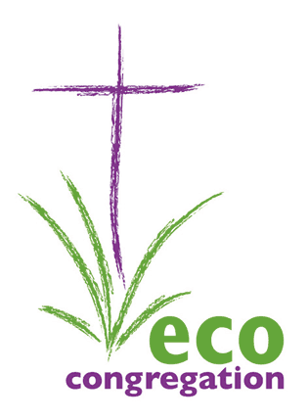
IRELAND

An environmental check-up
for your church
2017 edition

Welcome to Eco-Congregation Ireland!

This section has been developed to help you get started as an eco-congregation. It will
- help you identify and affirm the environmental work you are already doing with your congregation, church centre and/or church offices
- give you advice on how to develop and grow as an eco-congregation
- show your areas of strength and those that can be further developed
- point you to help for the areas you want to get involved in.

It is not a test! It is here to help you.

To become an eco-congregation, we recommend you form a small group to work through the check-up and prioritise your next steps. When you have done this, send us your registration form.

The environmental check- up

Use the following four key areas to identify your church’s current environmental good practice and future priorities. For some questions you may wish to tick more than one box (e.g. an environmental feature may be present but also have the potential to be further developed). There is space for additional notes on each. Skip those sections or tick boxes that aren’t relevant for your church.

Remember It’s not a test! Just pointers to help you get started…..

1. SPIRITUAL
Worship is the prime focus of Christian life from which the Church’s life and mission flows. This section is designed to help you identify how thankfulness and concern for God’s creation are expressed in your worship.

How regularly during the year are environmental concerns included in worship?
□ Never □ Only at special services □ every few months □ Frequently
e.g. Harvest Festival

In your Church’s prayer life, do you:
□ Praise God □ Say sorry for the □ Give thanks to God for □ Pray for the as creator harm done to the the gift of creation healing of environment creation

Which of these worship ideas have you used?
□ outdoor services □ prayer walks □ Using natural materials □ Choosing local
within worship bread for Communion

Does your Church sing hymns or songs that celebrate the wonder of creation and express the calling to care for the environment?
□ Regularly □ On special □ Hardly ever
Sundays

Does your Church observe Creation Time (1st September to 4th October)?
□ Every year □ Some years □ Hardly ever □ Never

Does your church: Have done Could consider
use Christian environmental resources
eg. On this website □ □

participate in workshops
that include environmental issues? □ □

include creation/environmental issues in its
teaching, studying or preaching programme? □ □

Undertake an environmental Bible study □ □
Invite a speaker on environmental issues □ □
Organise/participate in a creation-care Lent group □ □

Notes:
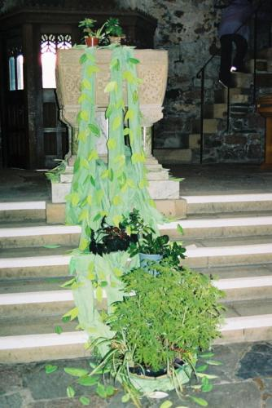

2. PRACTICAL

Church Buildings Have done Could consider
Insulate church buildings wherever possible □ □
Choose appropriate sized rooms for activities □ □
Read your meters regularly/ assess your energy usage □ □
Timetable meetings to minimise heating use □ □
Heating system with timer and thermostatic controls □ □
Fit energy saving light bulbs □ □
Encourage building users to switch off unnecessary
lights and not leave items on stand-by (e.g. photocopier) □ □
Check water outlets – fix drips and leaks □ □
Install water-saving devices (e.g. dual flush toilets and
low spray flow or auto turn-off taps) □ □

Purchasing policy
Use environmentally-friendly cleaning materials & paint □ □
Purchase recycled paper and envelopes □ □
Purchase Fairtrade products (e.g. tea and coffee) □ □
Use local suppliers where possible (so promoting a
sustainable local economy and reducing transportation) □ □
Catering
Use crockery rather than disposable cups and plates □ □
Use farmers markets and other local suppliers (to promote
local economy and reduce food miles) □ □

Waste minimisation
Collection facilities for recycling items which can be used by
church members, building users or local community
(e.g. paper, cans, printer cartridges, clothes, shoes, foil) □ □

Church Land
Wildlife-friendly management (e.g. minimal use of
weedkillers and pesticides, leaving some areas unmown,
valuing old trees, hedges, walls and stones) □ □
Native plant species and plants that benefit wildlife
(e.g. flowers used by moths and butterflies, berry-bearing
trees for birds, hawthorn and blackthorn) □ □
Used the All Ireland Pollinators programme? □ □
Other features to benefit wildlife (e.g. bird feeding station,
bird nest boxes, bat boxes, piles of leaves and rotting logs
for insects and hedgehogs) □ □
Visually attractive planting/ features □ □
Area for prayer/ contemplation/ outdoor worship □ □
Area for recreation □ □

Getting the message across Have done Could consider
Publish green tips in a church/ parish magazine □ □
Promote awareness through posters or information from
environmental organisations (e.g. home energy audit) □ □
Encourage recycling by providing collection points or
informing people of civic facilities □ □
Encourage walking and cycling to church □ □

All ages
Have you considered how children, young people, and the elderly
could be involved in all the above? □ □

3. COMMUNITY
Churches can work with and through their local community to improve their neighbourhood. Here you can assess the links that your church already has in the local community and the potential for further development.

Have done Could consider
Establish links with community organisations with a
view to sharing your environmental ministry
(e.g. schools, youth groups, local environmental bodies) □ □
Advise building users of your environmental concerns
and request that they utilise any environmental facilities □ □
Participate in local environmental initiatives or policy
formation – local authorities can advise □ □
Draw on links that members have with environmental
bodies (e.g. Tidy Towns, Friends of the Earth, Wildlife Trust) □ □
Support or initiate community schemes with a positive
environmental element (e.g. An Taisce spring clean-up,
Tidy Towns, local exchange trading systems, barter websites) □ □

Show a film on an environmental issue □ □

Notes:
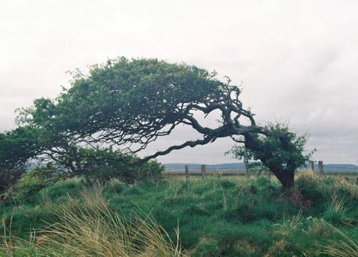

4. GLOBAL

Living simply that others may simply live is an integral part of Christian life.

What can your church do to benefit the environment and people across the world?

Have done Could consider Support the work of Christian development agencies
(e.g. Trόcaire, Christian Aid, Tearfund, VITA) □ □

Initiate or participate in activities in One World Week □ □
Promote Fairtrade □ □
Explore environmental issues through linked overseas
communities or churches □ □
Support the work of international conservation and
environment agencies (e.g. A Rocha, WWF, Friends of the Earth) □ □

Notes:

CONGRATULATIONS on all the work you are already doing to care for the environment!
For further assistance see our website
For admin, support and funding purposes, it would be helpful if you could print and send this page with your details to Karen Nicholson, 45 Belvoir Drive, Belfast BT8 7DH or scan it and send to info@ecocongregationireland.com

Full Name of Church ...................................................................................................

Denomination of Church ............................................................................................

Title and Name of Contact Person..............................................................................
(Environmental Coordinator)

Address of Contact Person.........................................................................................

.......................................................................................................................................

County .................................................. Post/Eircode .....................................................

Tel: .....................................…….... Mobile:…......................................................

Email address:....................................................................................................

Size of Church (members/regular worshippers) Under 50 □ 51-200 □ 200+ □

Location: Rural □ Suburban □ Town/City Centre □ Inner City □

Name of your Local Authority: ...................................................................................

Name of Church decision-making body which approved this order:

.......................................................................................................................................

Date of Meeting: ..........................................................................................................

Position of Church Officer chairing the meeting: …………………………….…………………….

I affirm that environmental issues/caring for God’s creation form part of our church’s life and mission and that we have worked through the churches environmental check-up in module 1 or a comparable environmental audit

Name of Church Officer:………………………………………………………….

Signature of Church officer:……………………………………………………..
For further information contact:

Karen Nicholson
Administrative Officer
45 Belvoir Drive
Belfast BT8 7DH

Email:info@ecocongregationireland.com
Tel: 089 974 0744

Website: www.ecocongregationireland.com

Eco-Congregation Ireland is an inter-denominational project operating under the auspices of the Church in Society Forum – a standing committee of the Irish Inter-Church Meeting.

Eco-Congregation Ireland is grateful to have received financial support over the
years from Trócaire, Christian Aid, the World Day of Prayer, the Franciscan Province of Ireland, the Church of Ireland Priorities Fund, the Presbyterian Association Foundation,
the Home Mission Department of the Methodist Church in Ireland, Irish
Quaker Faith in Action, Robert and Kezia Stanley Chapman Trust and
Dublin Monthly Meeting Concerns Fund as well as the small
annual subs from the Roman Catholic, Church of Ireland,
Presbyterian and Methodist Churches in Ireland and the
Religious Society of Friends (Quakers) in Ireland.

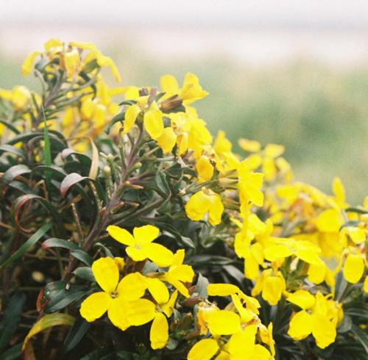

ALL PHOTOS © ANIKÓ SCHUETZ

